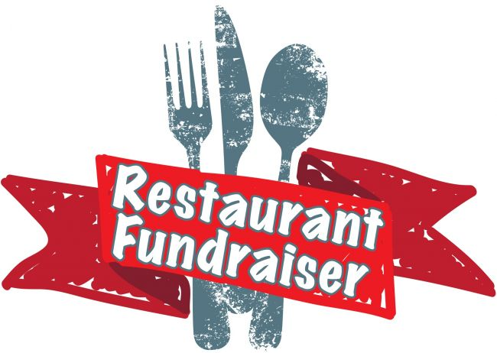

Support Kihei Charter Schools!
Bring in a picture or a print
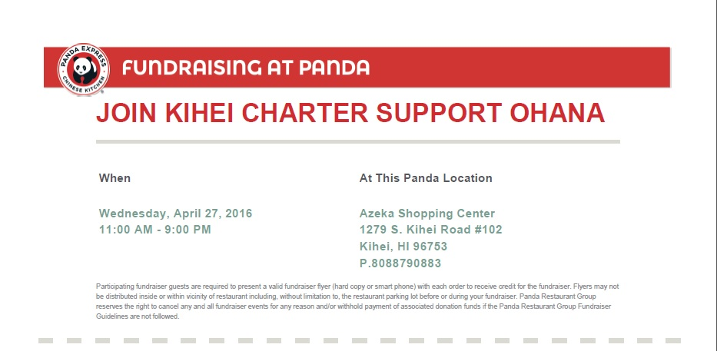
out of this fundraising slip!

Order yummy food at Panda Express and
PLEASE show the fundraising slip to the cashier before you pay.

100% of the funds earned will go to support students, teachers,
and programs at the three Kihei Charter School campuses.
Mahlo for your support !

